Ideation Phase

Brainstorm & Idea Prioritization Template

|  |  |
| --- | --- |
| Date | 19 September 2022 |
| Team ID | PNT2022TMID39010 |
| Project Name | Signs With Smart Connectivity For Better Road Safety |
| Maximum Marks | 4 Marks |

Step-1: Team Gathering, Collaboration and Select the Problem Statement

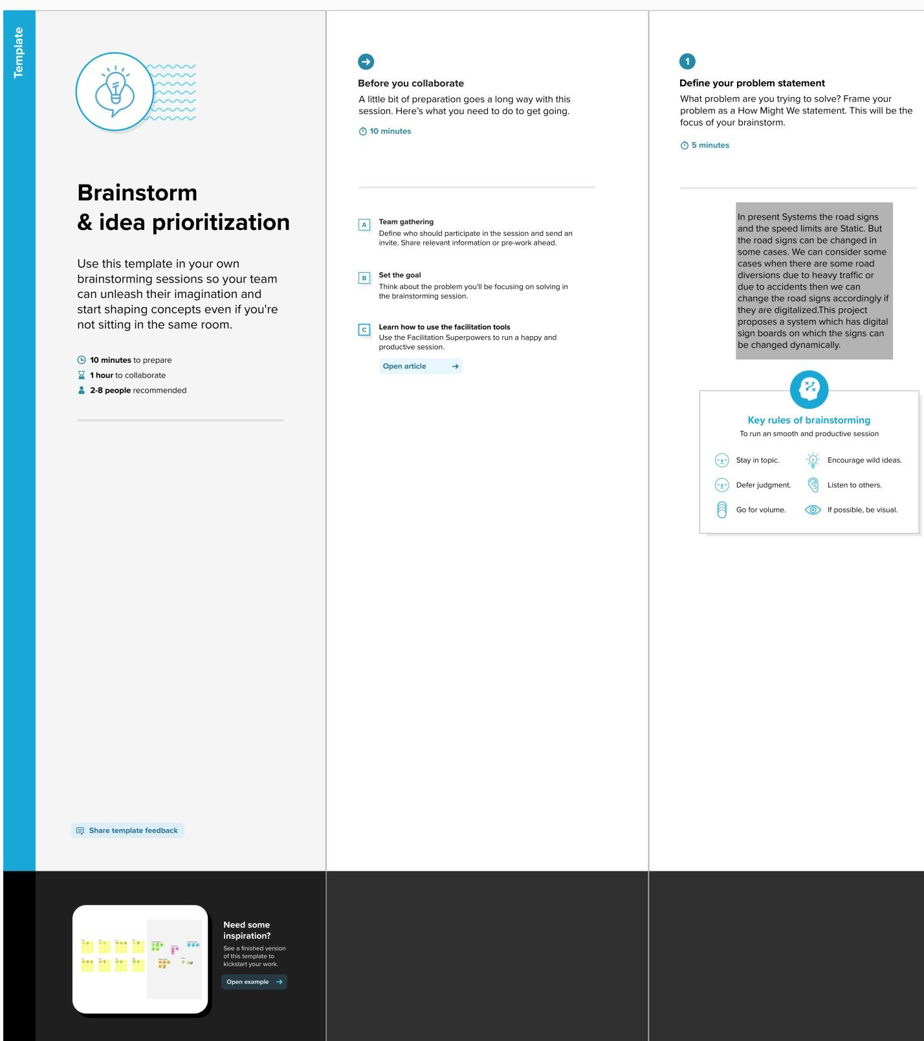

Step-2: Brainstorm, Idea Listing and Grouping

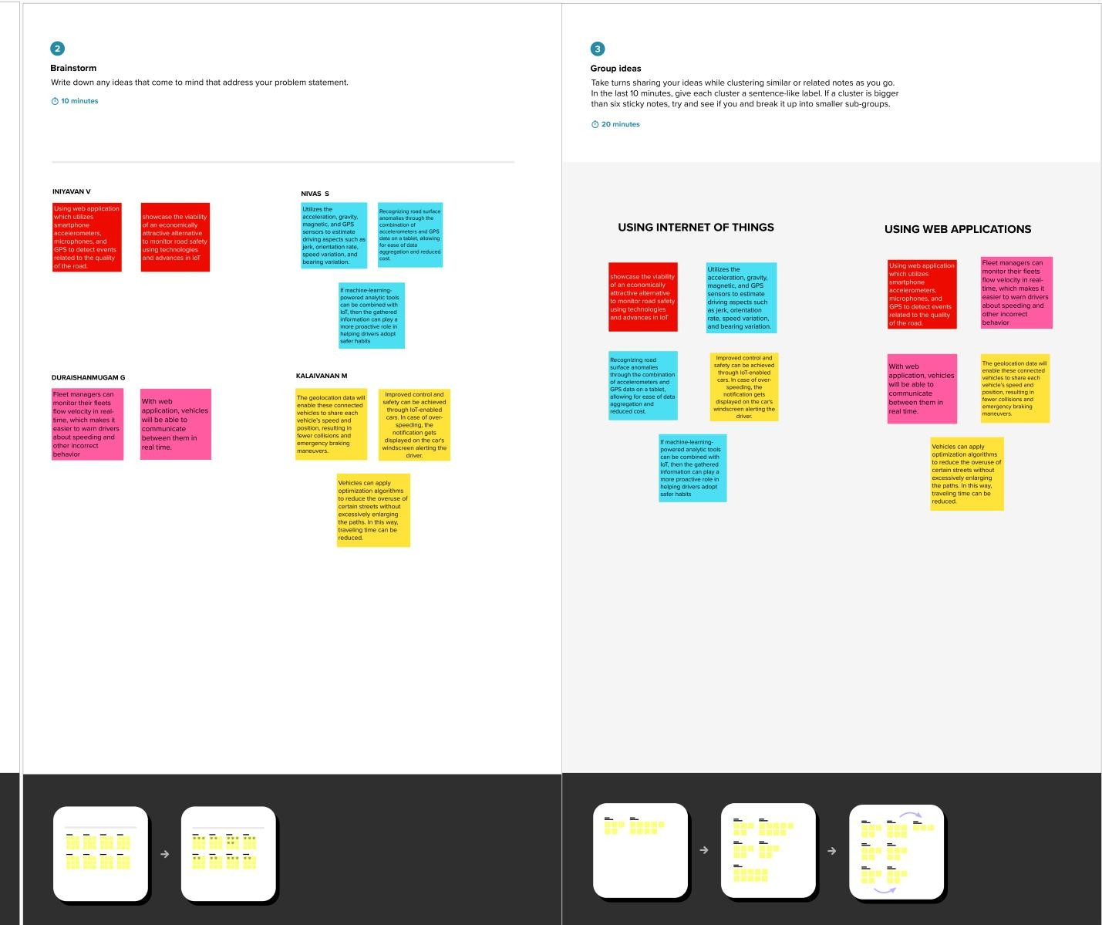

Step-3: Idea Prioritization

